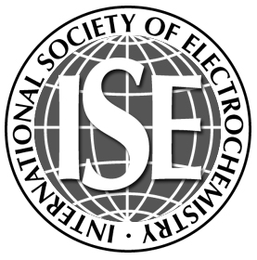 | International Society of Electrochemistry  Rue de Sébeillon 9b, 1004 Lausanne, Switzerland  Fax: +41 (21) 648 3975  e-mail: info@ise-online.org
Corporate and Corporate Sustaining Membership 2017

Important: All fees are in EUROS. Subscription prices have to be added to the membership fees.
Tick appropriate boxes, add amounts and your name and address, mail or fax this form to the ISE Office.

Membership fees
■ Corporate Members (includes Electrochimica Acta online) 300.00
■ Corporate Sustaining Members (includes Electrochimica Acta online) 500.00

Journal Subscriptions (1 January – 31 December 2017) PRINT ONLINE
Electrochimica Acta  free
J. Electroanalytical Chemistry  245.00
Electrochemistry Communications  50.00
Bioelectrochemistry  50.00
Package (*)  282.00
(* includes J. Electroanalytical Chemistry, Electrochemistry Communications, Bioelectrochemistry)
Journal of Power Sources not available  100.00
J. Solid State Electrochemistry  457.00 not available
J. Applied Electrochemistry  215.00 not available
Electrocatalysis  67.00 not available
8% VAT (for countries in the European Community)
Please use the online subscription order form to calculate the exact VAT for countries in the UE.
No subscription order will be processed without the proper VAT amount.
Total EURO

Company Name: _____________________
Member ID: _______________________________ | Member ID: _______________________________
First name:________________________________ | First name:________________________________
Last name:________________________________ | Last name:________________________________
e-mail:____________________________________ | e-mail:___________________________________
Country:__________________________________ | Country:__________________________________

Mode of payment
■ By credit card
■ VISA  EuroCard/MasterCard | Expiration date | Month: |  |  | Year:

Card number

Date: ____________________________ Signature:_______________________________
■ By Bank transfer
Remittance to: Bank: UBS SA, Case Postale, CH-1002 Lausanne, Switzerland
Account no: 287-M1224343.0
SWIFT code: UBSWCHZH80A
IBAN code: CH54 0028 7287 M122 4343 0

