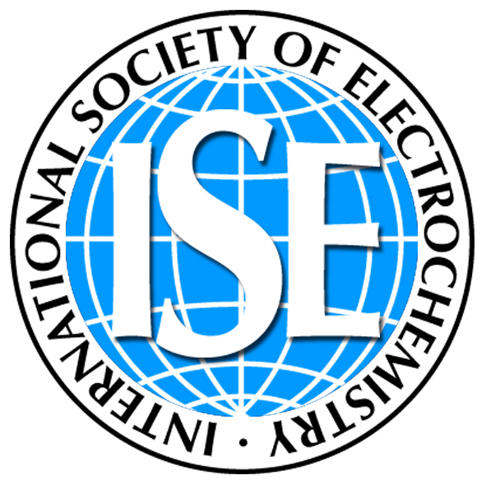 | International Society of Electrochemistry  associated organization of IUPAC  Chemin du Closelet 2 E-mail: info@ise-online.org / events@ise-online.org  CH-1006 Lausanne Web: http://www.ise-online.org  Switzerland

Date

Re: Keynote Lecture
71st Annual Meeting of the International Society of Electrochemistry
"Electrochemistry towards Excellence"
30 August-4 September 2020, Belgrade, Serbia

https://annual71.ise-online.org/
e-mail: events@ise-online.org

Dear xx,

As symposium organizers, we would like to invite you to present a Keynote Lecture in the symposium x: Symposium title that we are organizing within the 71st Annual Meeting of the International Society of Electrochemistry. The annual meeting will be held from 30 August to 4 September 2020, in Belgrade, Serbia.

Our symposium will cover the areas of …

If you are able to accept our invitation to present this Keynote Lecture please reply by XXXXXX. The abstracts will be accepted by submission via the internet (https://annual71.ise-online.org/) until 20 March 2020, as the final deadline for abstract submission.

Finally, we regret to tell you that we have no funds available to assist keynote speakers with their registration, travel and accommodation expenses.

We look forward to hearing from you.

Best wishes,

Coordinator of Symposium x
ISE 71st Annual Meeting

