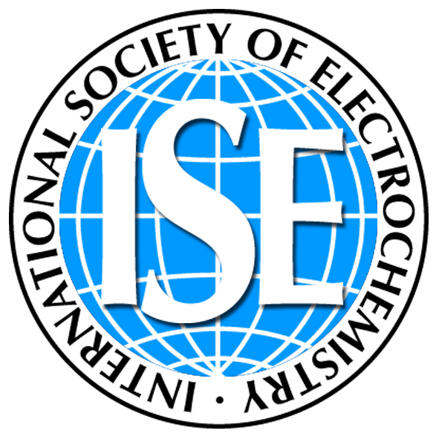 | International Society of Electrochemistry  associated organization of IUPAC  Chemin du Closelet 2 Fax: +41 21 648 39 75  CH-1006 Lausanne E-mail: info@ise-online.org / events@ise-online.org  Switzerland Web: http://www.ise-online.org

Date

Re: Plenary Lecture
XXth Annual Meeting of the International Society of Electrochemistry
Conference date
City and Country of venue
Conference title

http://annualXX.ise-online.org
e-mail: events@ise-online.org

Dear xx,

It is my greatest pleasure and honour to invite you to present a plenary lecture at the 65th ISE Annual Meeting “Conference title” to be held from August 31st to September 5th, 2013 at the SwissTech Convention Center located on the EPFL Campus in Lausanne, Switzerland.

As usual, this international conference will cover traditional and new areas of electrochemistry as represented within the seven Divisions of the Society: in general, from molecular and interfacial electrochemistry to sensors and biosensors, environmental topics, industrial processes such as power sources and energy conversion, and the development of new materials and nanotechnology.

As a plenary speaker, ISE will be pleased to cover your registration, banquet fees, accommodation in Lausanne and economy travel expenses.

We hope you will be able to accept this invitation to present your work to a wide audience of electrochemists and contribute to make this meeting a great success.

I look very much forward to welcoming you in Lausanne.

Best wishes,

Chair of the 65th ISE Annual Meeting

